**Batch 2: Group 1**

**Assignment 7**

**Aim:** Installing Git, First-Time Git Setup, Getting a Git Repository, Working with various git commands, Working with Local repository vs remote repository, Managing remote repository.

**Objectives:**

1. Gain proficiency in installing Git and configuring it for first-time setup to initiate version control for software projects.
2. Understand the process of creating, cloning, and interacting with Git repositories, both locally and remotely, to collaborate effectively with team members.
3. Master various Git commands for managing version history, branching, merging, and resolving conflicts to streamline the software development workflow.

**Theory:**

**Git Installation and Setup:**

Git is a distributed version control system widely used for tracking changes in source code during software development. Installing Git and configuring it for the first time involves setting user information, including name and email, and optionally configuring other preferences like default text editor and line ending settings.

**Working with Git Repositories:**

Git repositories can be created locally using "git init" or cloned from remote repositories using "git clone." Once a repository is initialized or cloned, developers can add, commit, and push changes to the repository, enabling collaborative development across teams. Git commands such as "git status," "git add," "git commit," and "git push" are essential for managing changes and synchronizing them with the remote repository.

**Local vs. Remote Repository Management:**

A local repository resides on the developer's machine and contains the complete project history. Developers can work offline, create branches, and experiment with changes locally before pushing them to the remote repository. Remote repositories, hosted on platforms like GitHub or Bitbucket, facilitate collaboration by providing a centralized location for sharing code, managing access permissions, and tracking issues and pull requests.

**Implementation:**

1. First we need to install git from - <https://git-scm.com/>

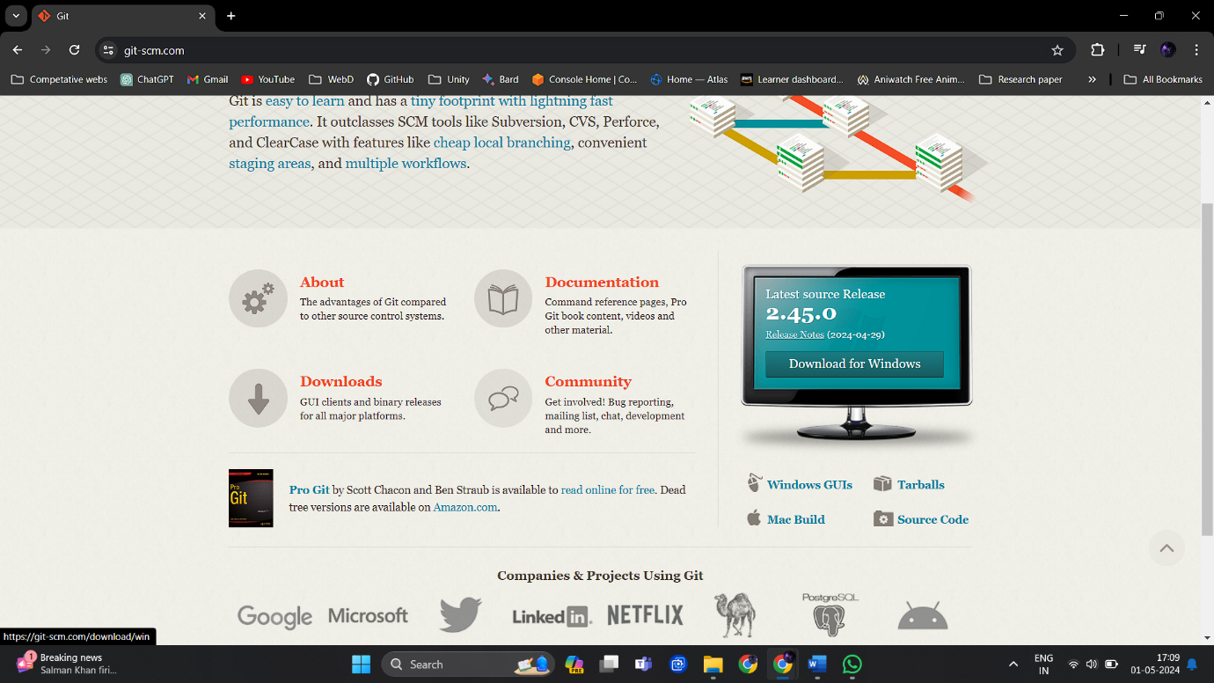

1. Choose download for windows and click on Click here to download.

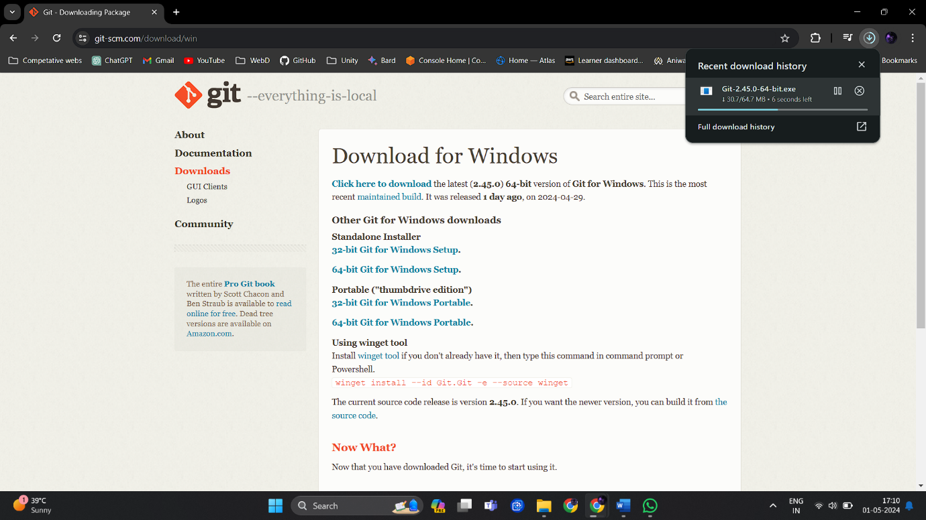

Once the application is installed open it.

1. Configure the path to install.

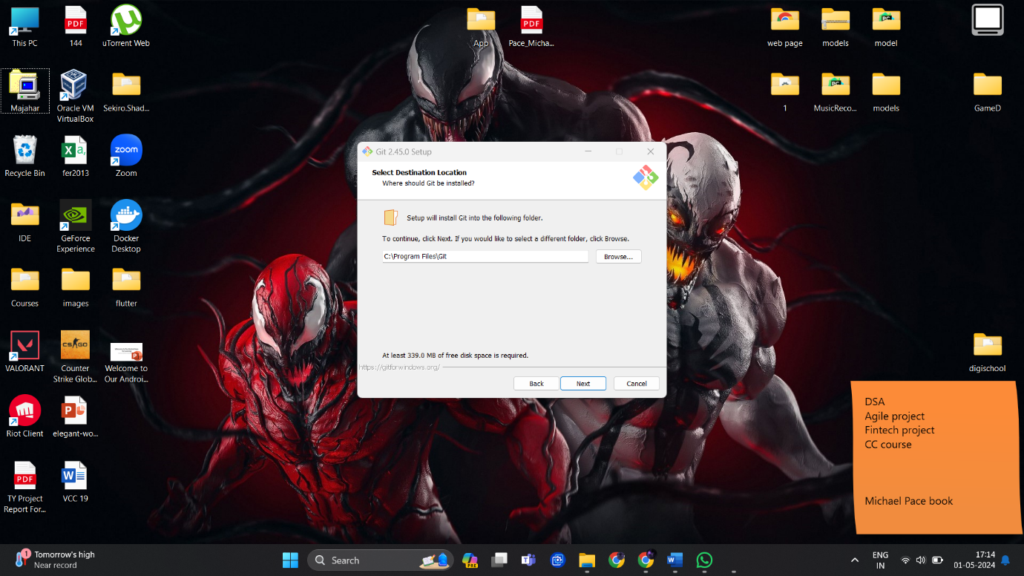

1. Add additional icon.

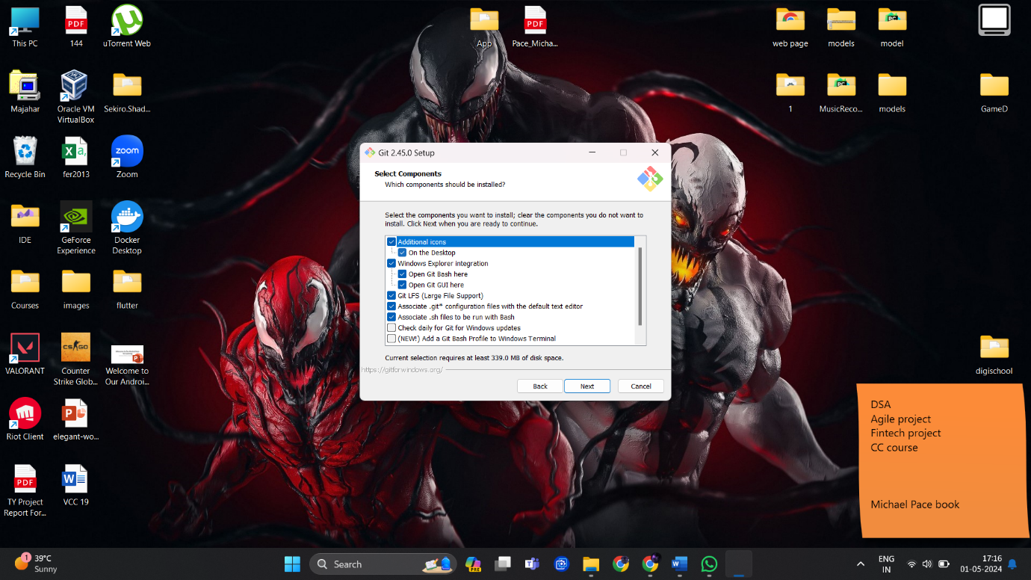

1. Give the name to git shortcut.

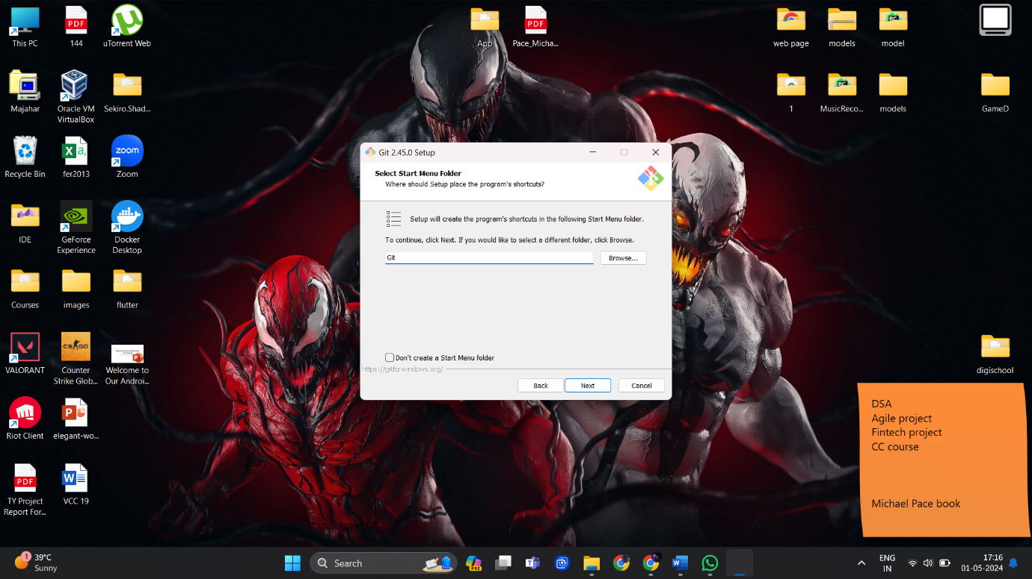

1. Choose the IDE, in our case we are going with Visual Studio Code.

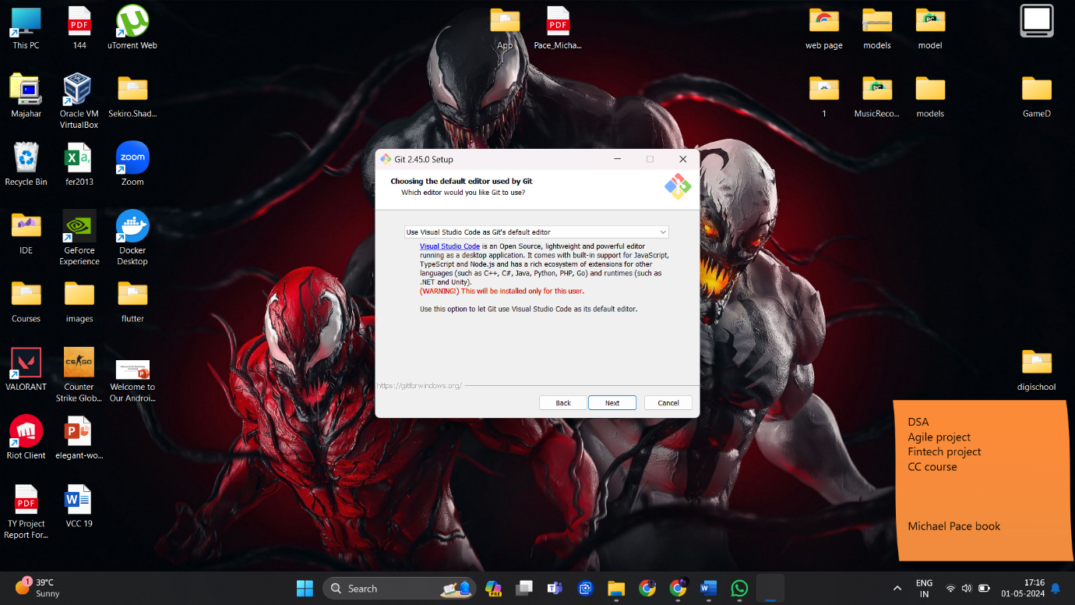

1. Override the default branch and name it main, as on Github we mainly use main branch.

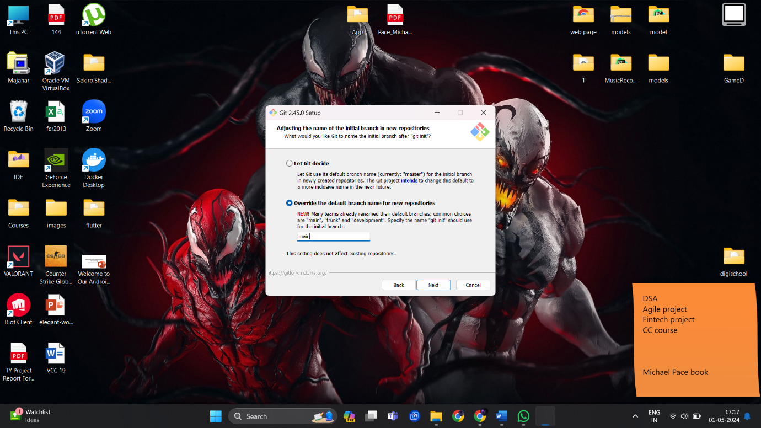

1. Select default setting until they ask for configuring experimental options.

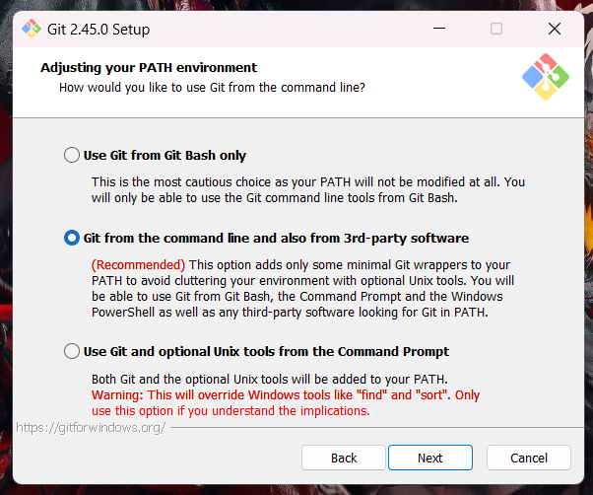 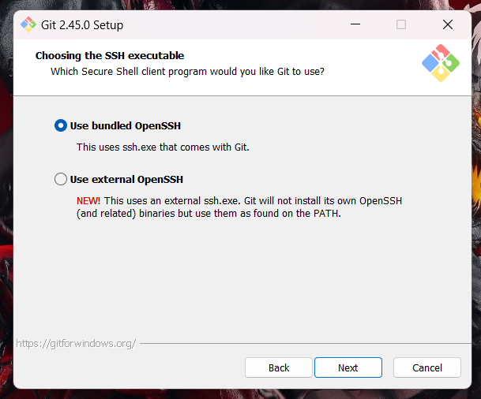

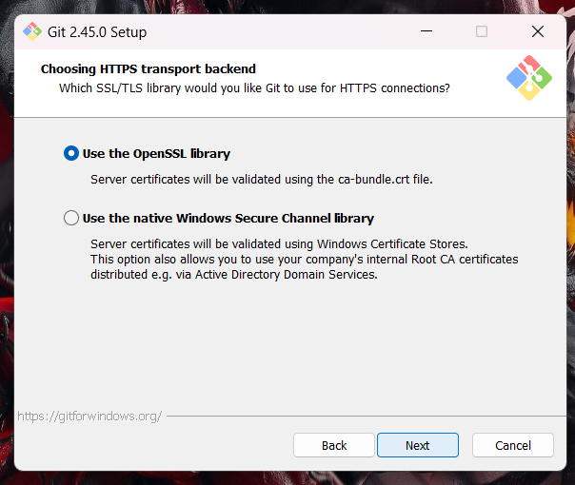 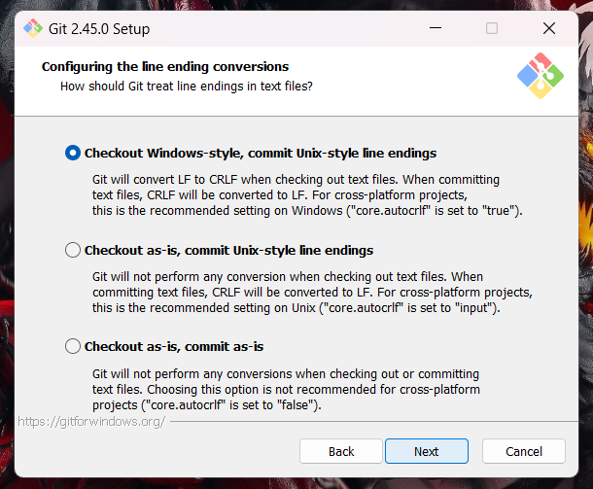

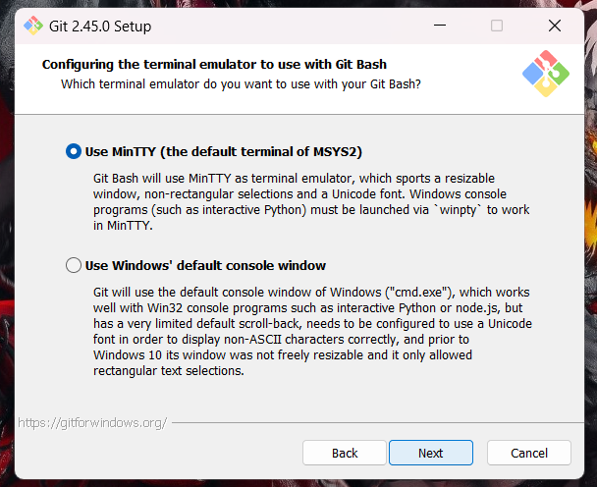 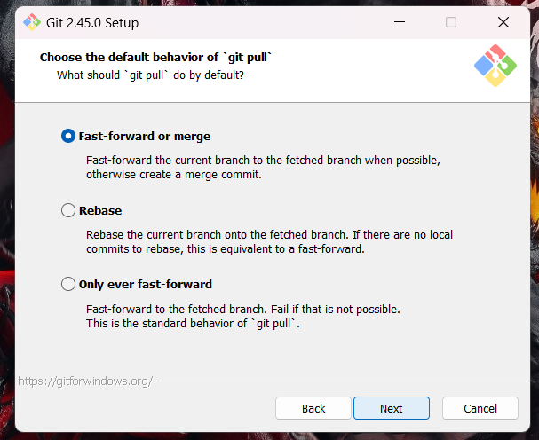

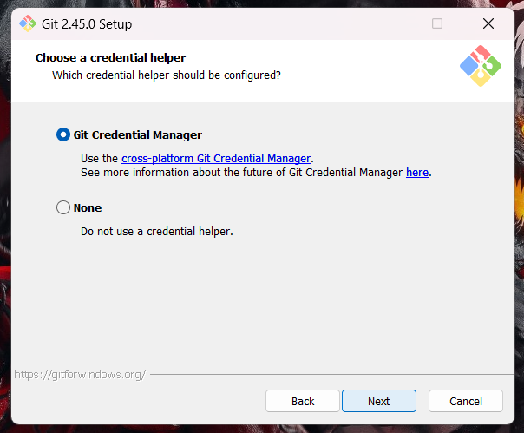 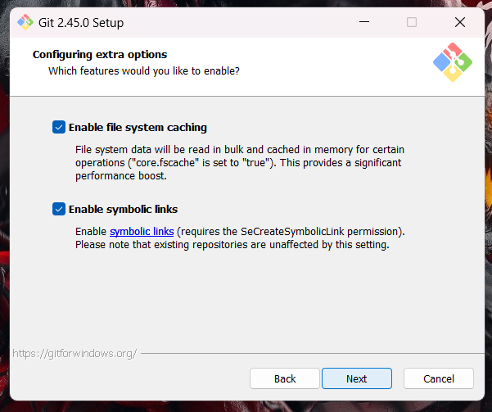

1. Enable both options and install.

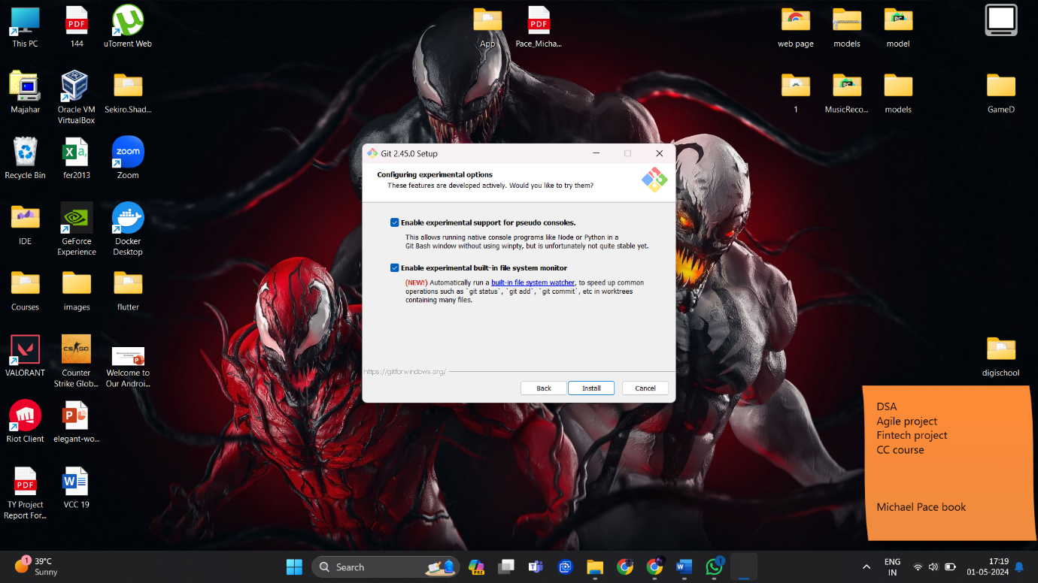

Now the installation is complete.

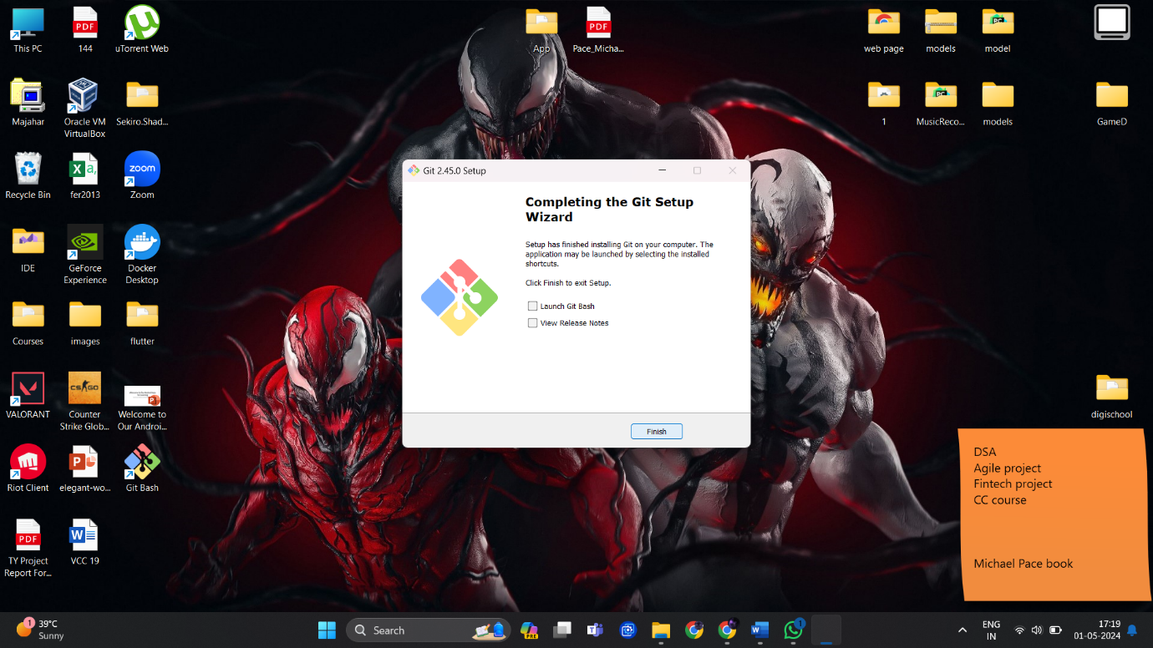

The next step is setting up git in our environment and connecting it to our GitHub.

1. Create a folder, add your application/code file to it and open the folder through git bash.

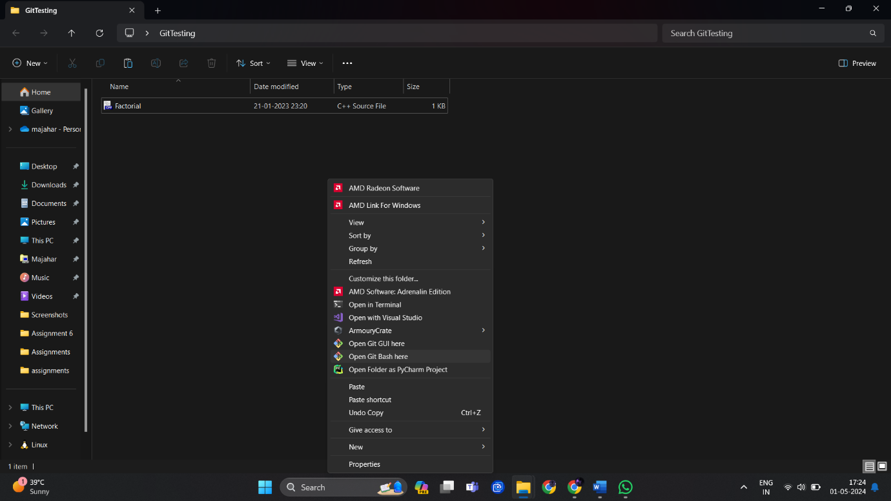

1. Initialize git by ‘git init’ command, you can see a .git file is created in your directory but is not visible in folder.

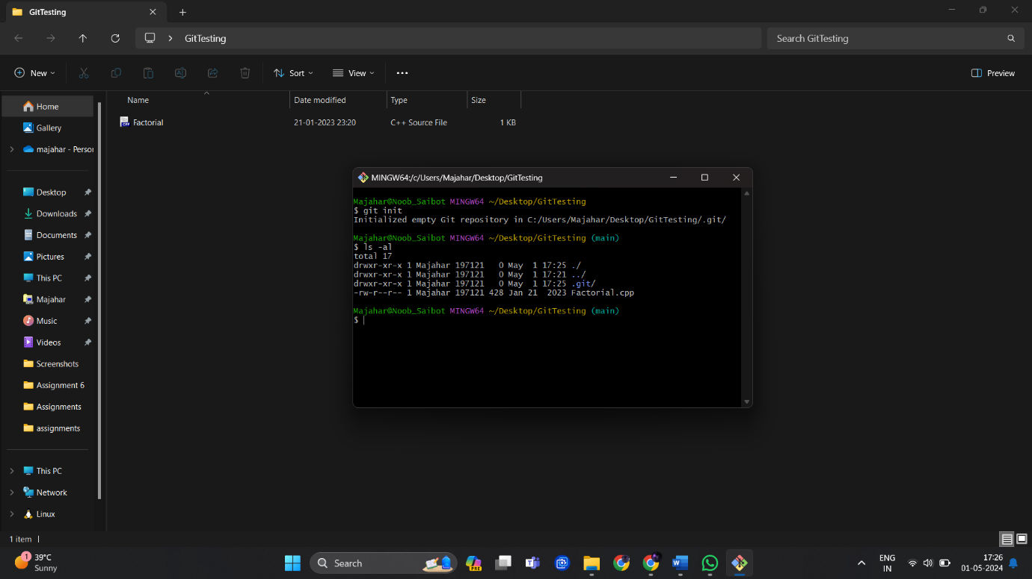

1. Check status.

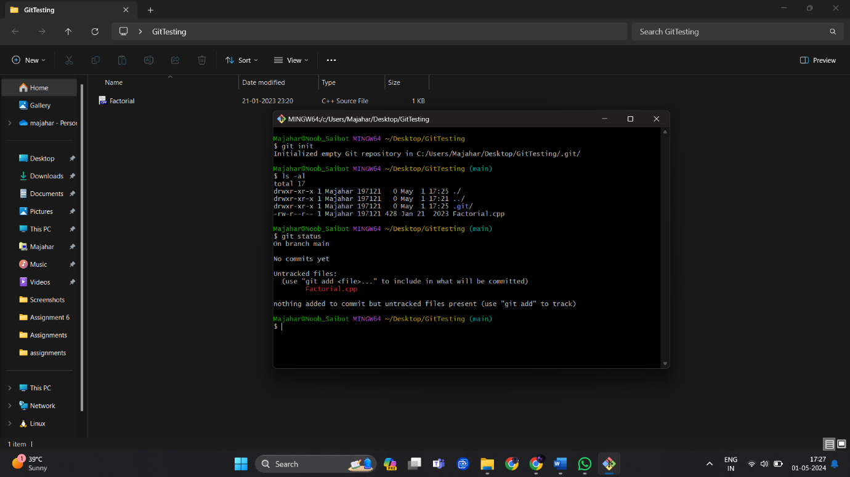

You can see that our Factorial.cpp file is untracked.

1. Add that file and check status again.

git add <File_name>

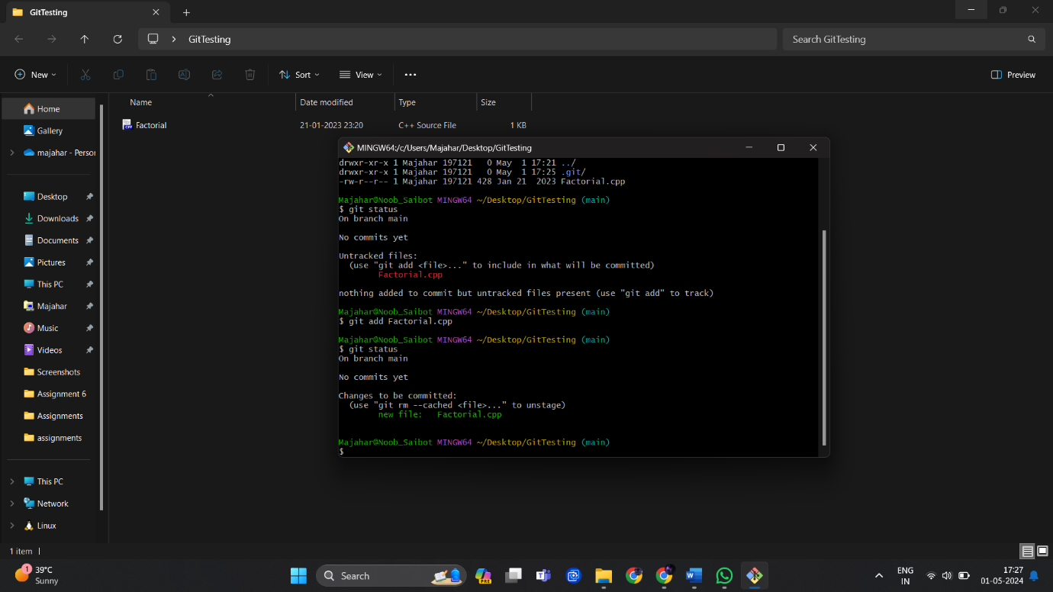

1. Now give email and username for user, and commit.

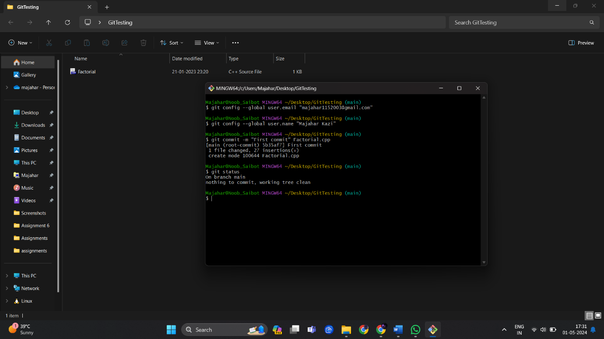

Check the status and you can see the working tree is clean.

1. Go to GitHub and create a repository.

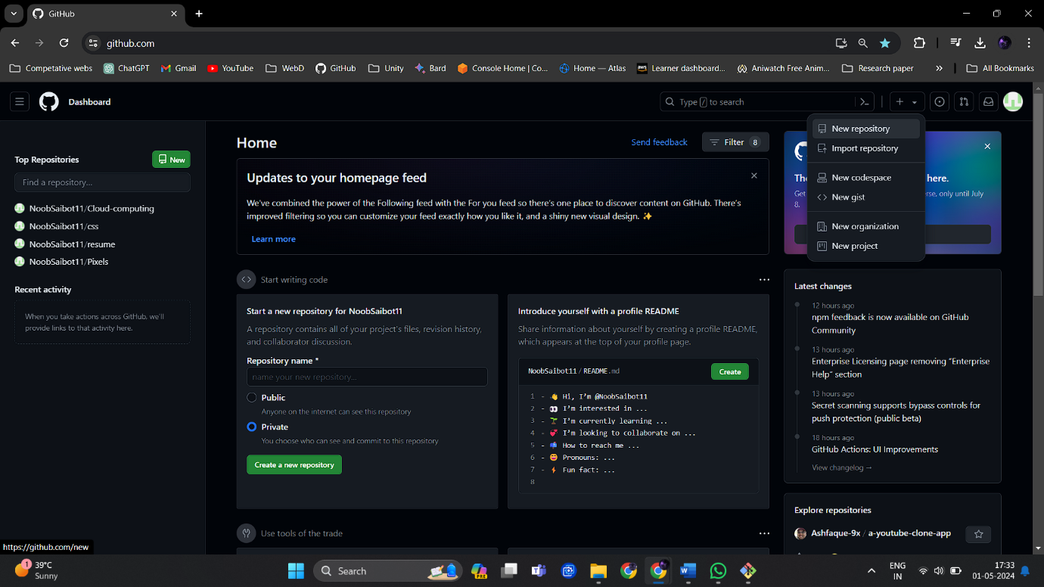

1. Give repo name same as folder name so that it will easy for understanding.

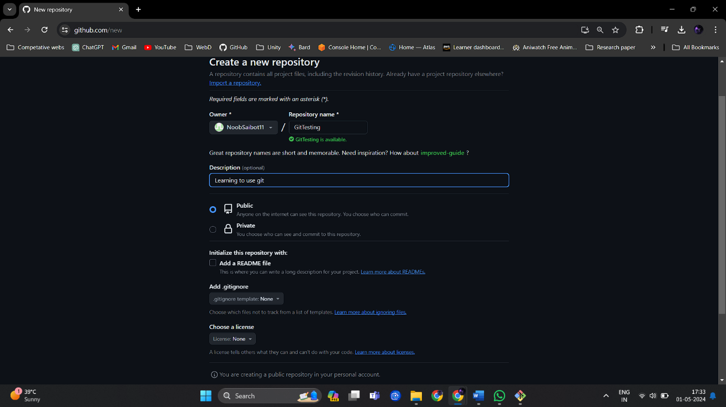

1. Now we need a GitHub token for accessing repo, for that go to settings and select developer settings.

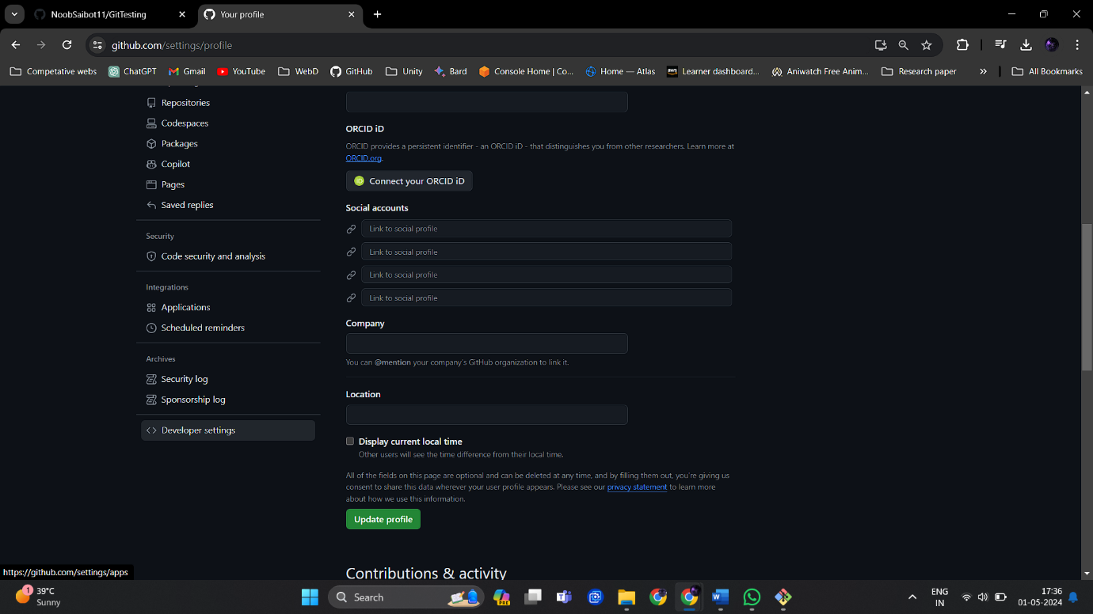

1. In the developer setting select classic token and generate classic token.

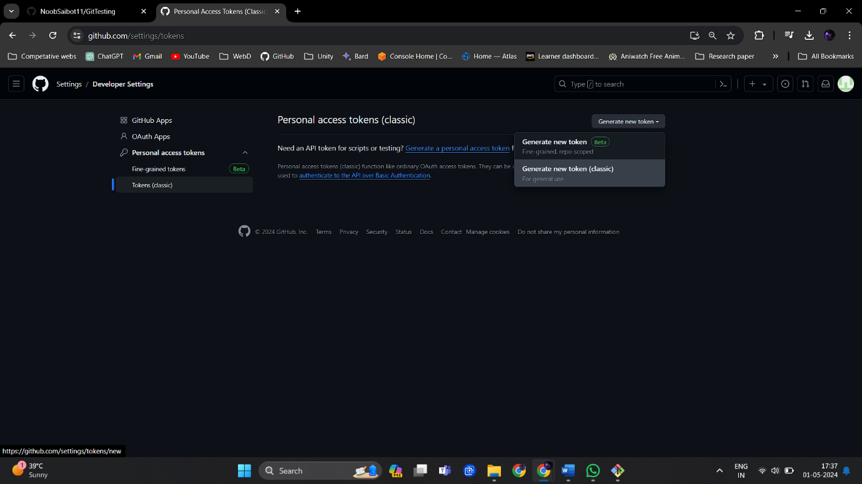

10.Give needed access to token and generate the token.

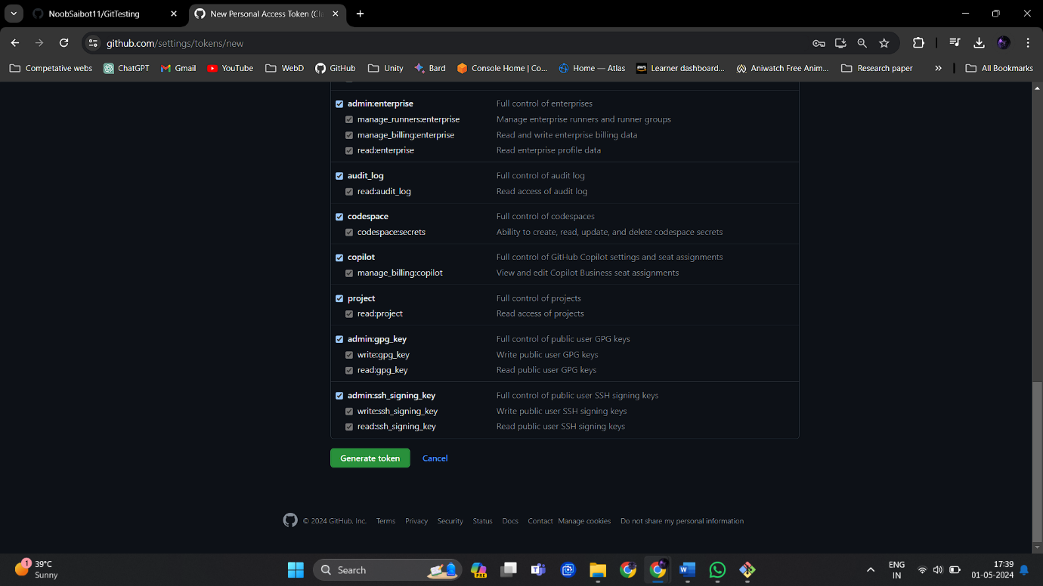

11.Copy and store the generated token somewhere as it will never again be shown.

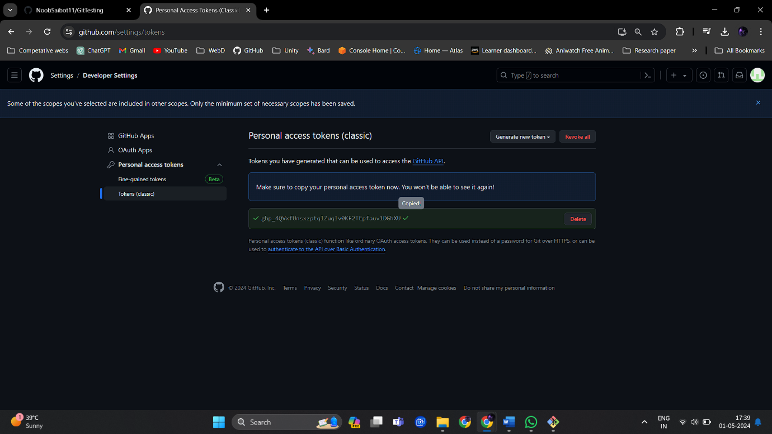

12.In bit bash add repo by command

git remote add origin <https://[Token]@github.com/username/repo_name>

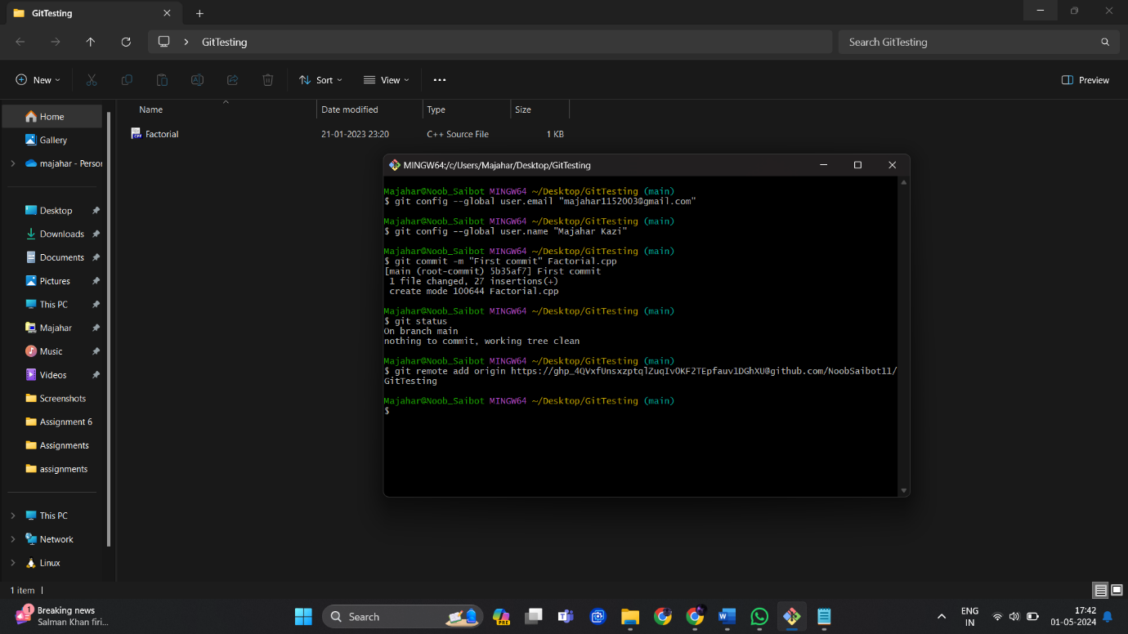

Here I am hiding token for security reasons.

13.Now push the changes.

git push -u origin main

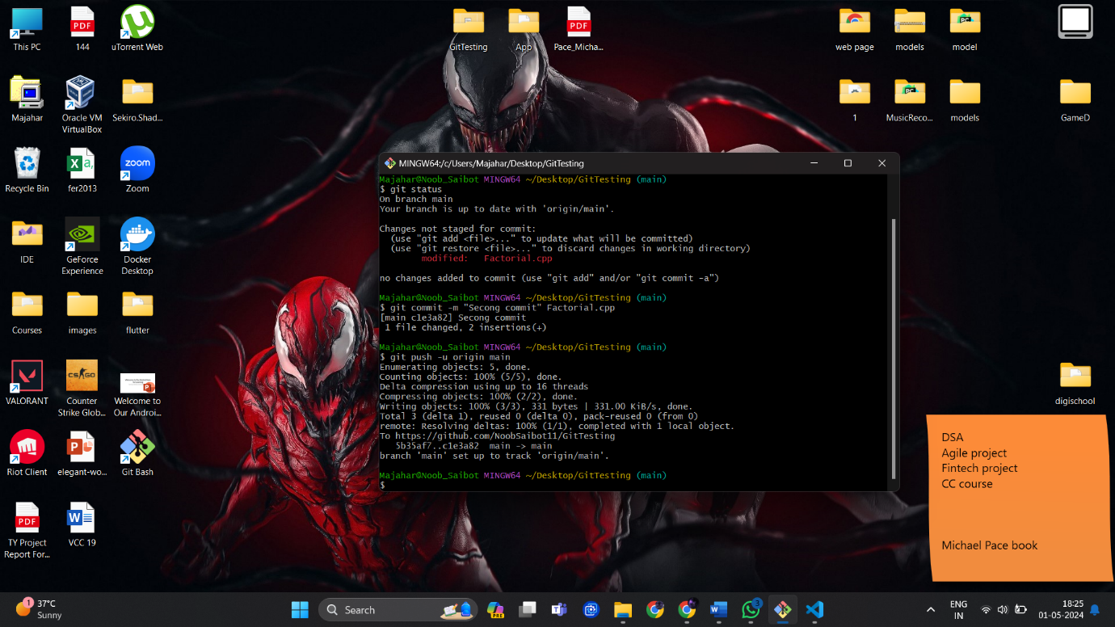

14.Once pushed check the repo.

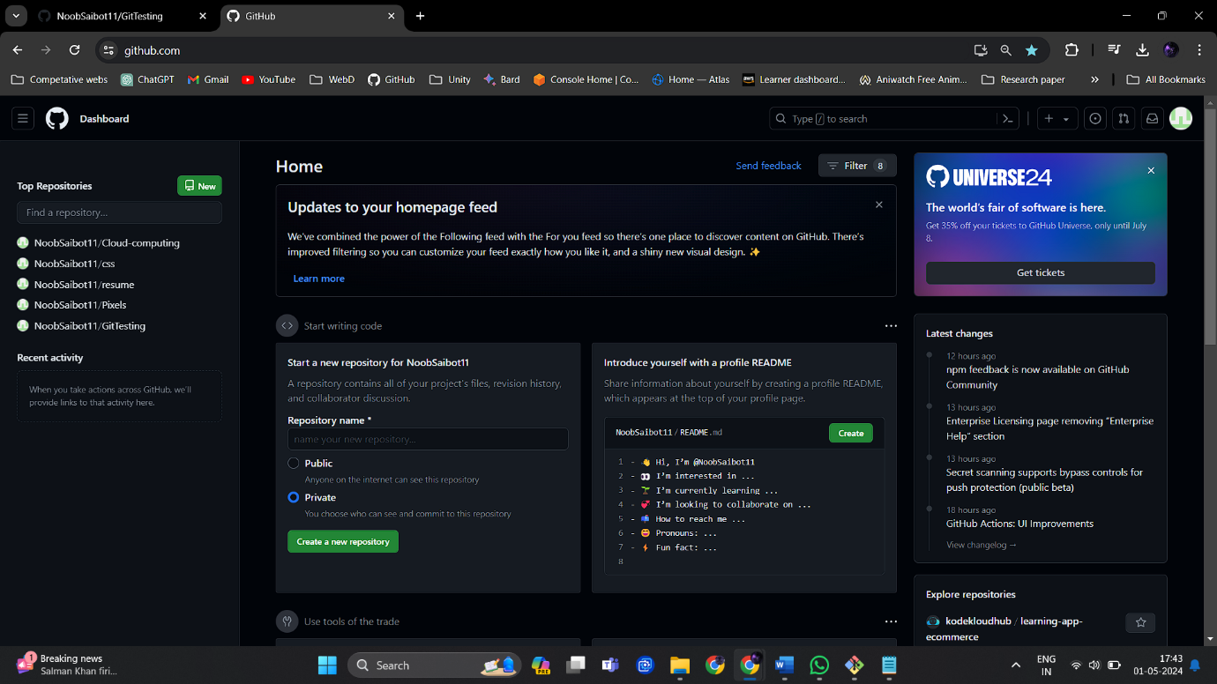

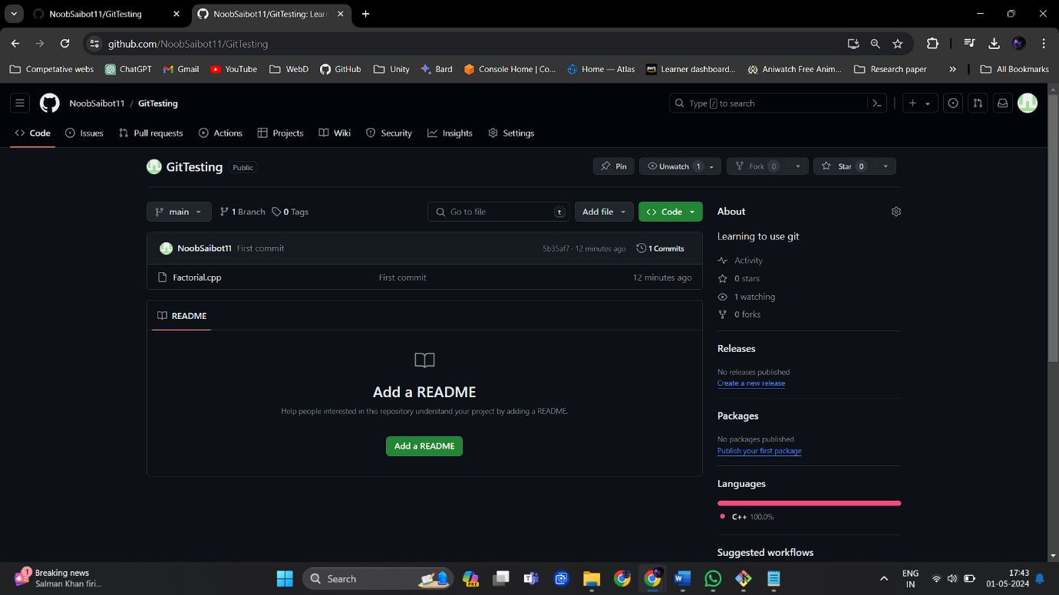

Our Factorial.cpp file is added to repository.

15. We can open our folder through our selected IDE by ‘code .’ command.

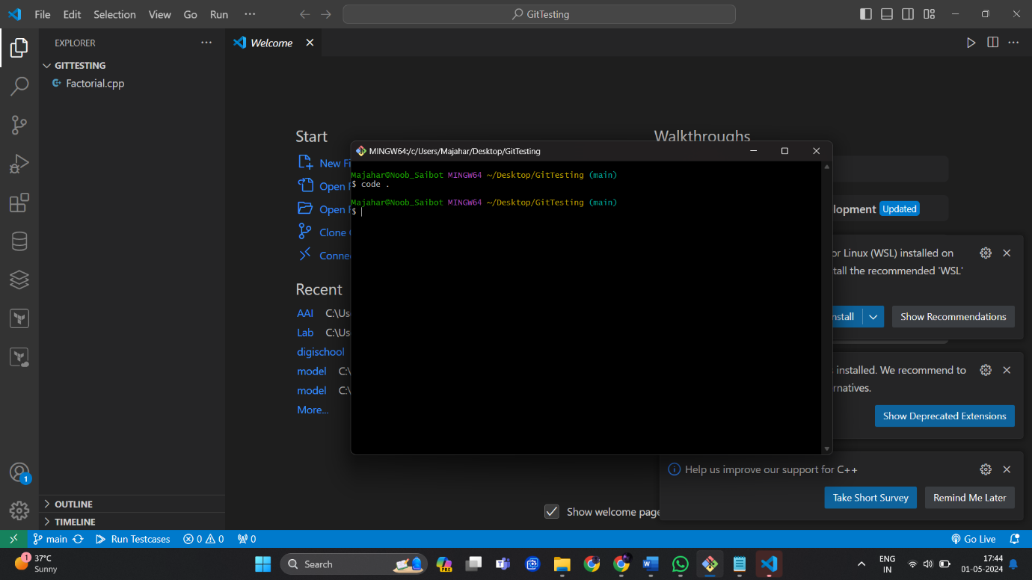

16.We can make changes in code file.

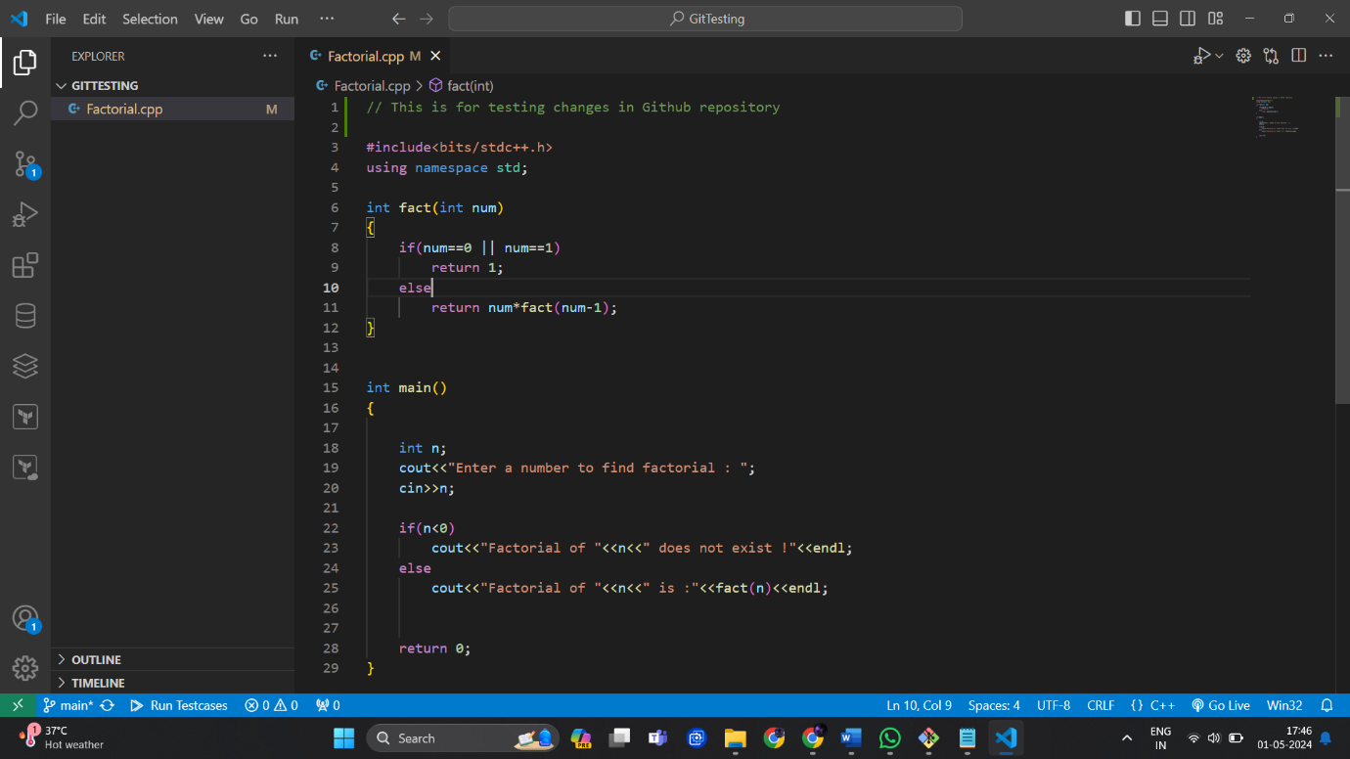

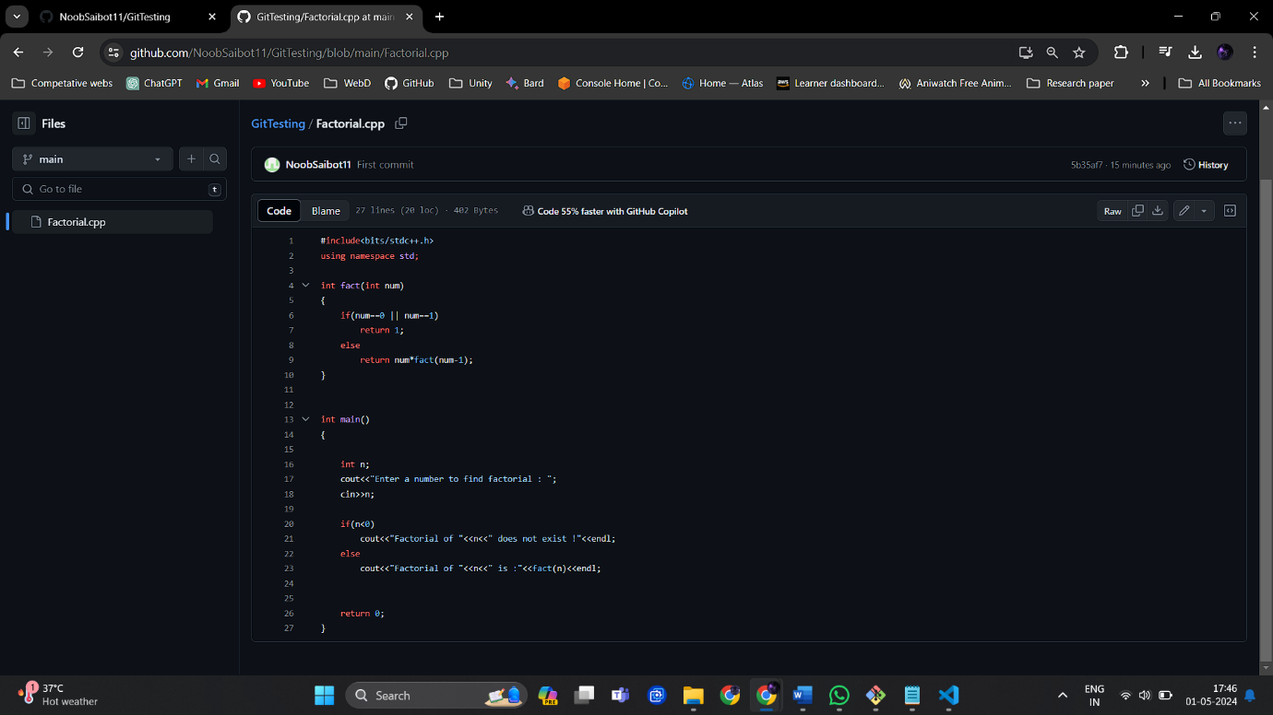

In GitHub there is no comment line in start.

17.Commit and push the changes so that repo can update.

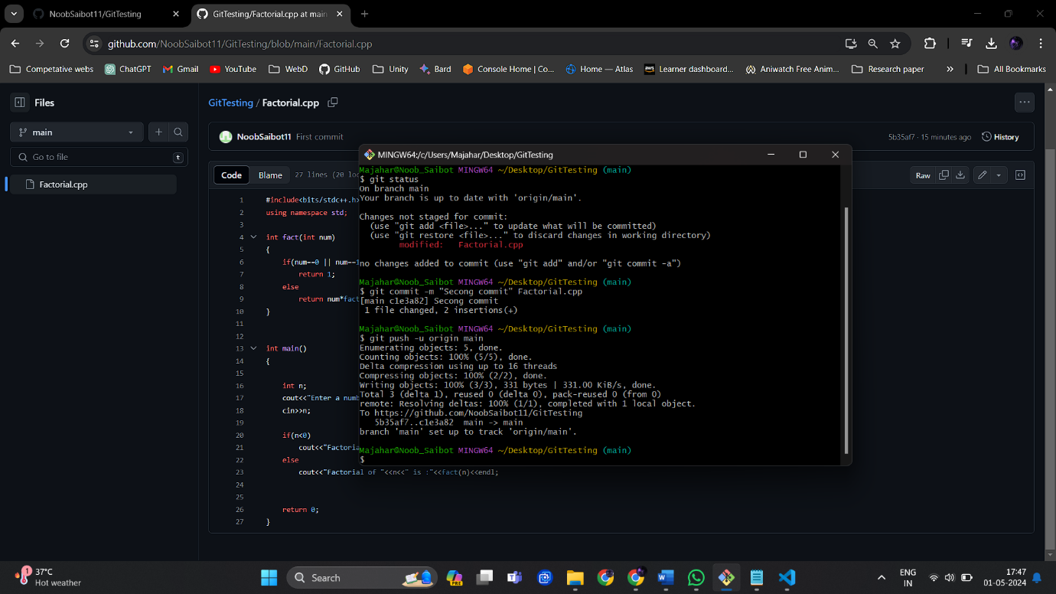

Refresh the page to update it.

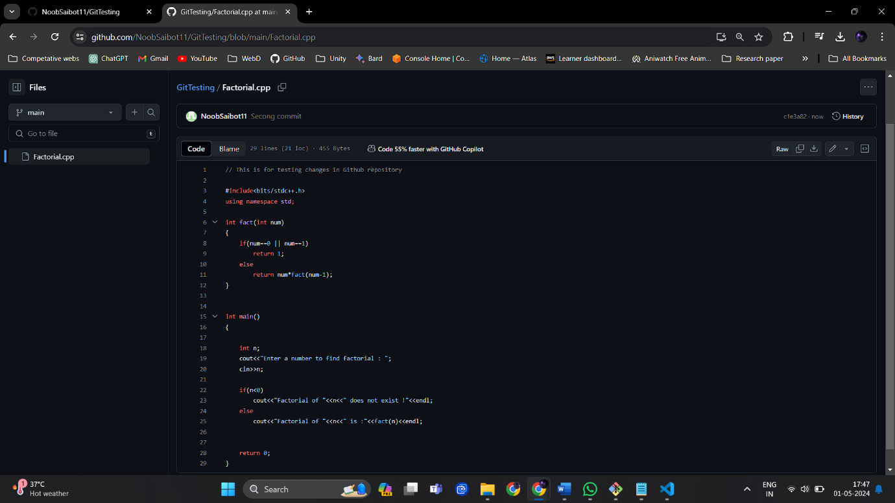

**Conclusion:**

Mastering Git fundamentals, including installation, repository setup, and command-line usage, is essential for modern software development practices. By leveraging Git's capabilities for version control, branching, and collaboration, teams can streamline their development workflow, reduce conflicts, and ensure the integrity and traceability of their codebase. Whether working locally or remotely, Git enables developers to efficiently manage project histories, collaborate with peers, and deliver high-quality software products effectively.